**Exercise - Introduction to Database**

**Problem Statement: There can be multiple customers, who can place multiple orders on the site. Now a sales person can handle these orders will distribute into multiple sales persons (One order will be assign to one salesperson only). So a sales person can have multiple orders of multiple customers.**

**Create Database**

Here we are creating a Database named  *bootcamp* using command *create database <database name>;*.

And command *show databases;* lists all the databases present in the system.

Screenshot(s)

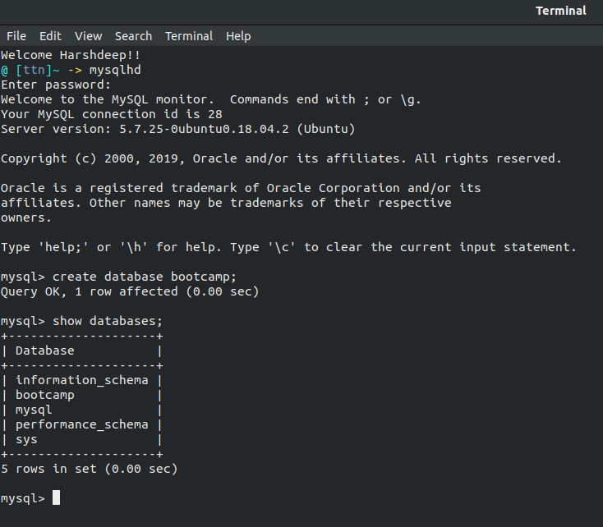

**Design Schema**

The Schema defines how a database should look like, what all relations are necessary for the database to work properly.

Here, the table *customers* is having customer details, the table *salesperson* is having details of the salesperson, and the table *order_details* is having the details for the order and both customer id and salesperson id as foreign keys from respective tables. Moreover, order id, salesperson id and customer id serve as a composite primary key in the table *order_details*.

Screenshot(s)

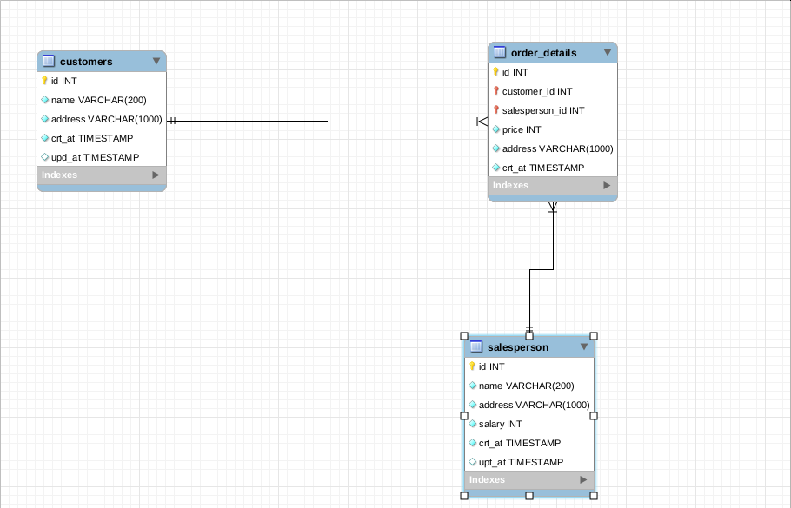

**Create tables**

We can create a table in mysl using the command *create table <table name> (<column_name> <data_type> <options>,....)*

Screenshot(s)

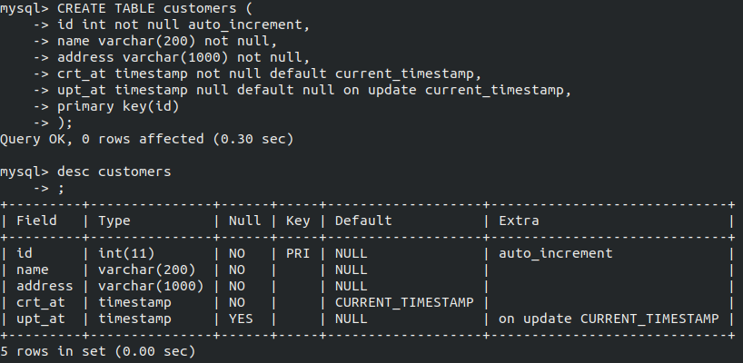

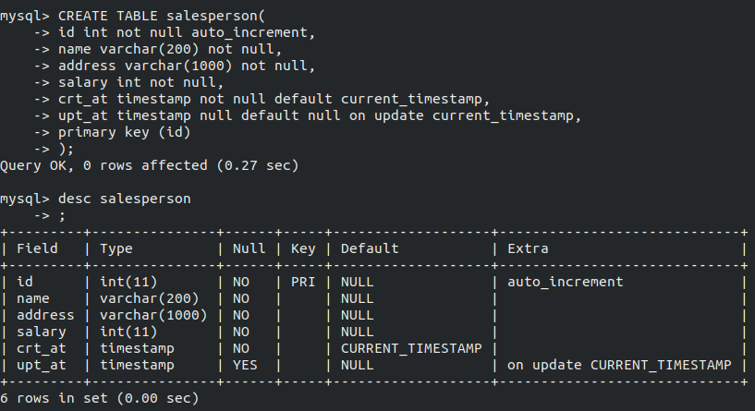

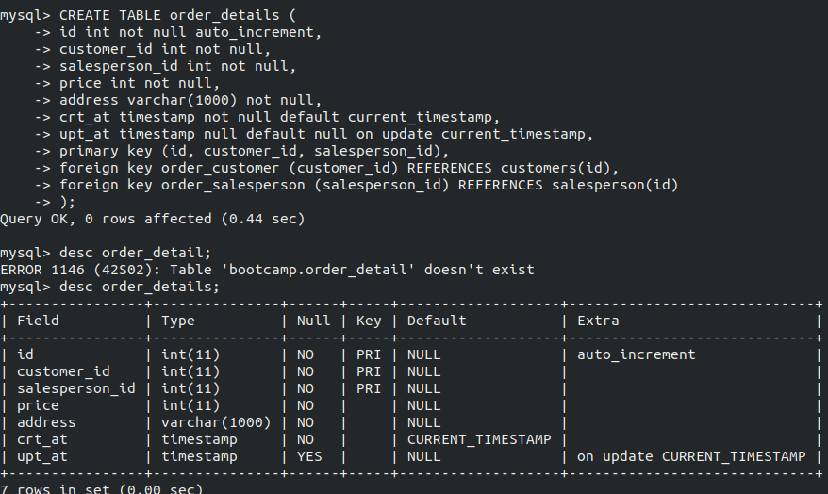

**Insert sample data**

Inserting sample data in all the tables, considering all the foreign key constraints.

Screenshot(s)

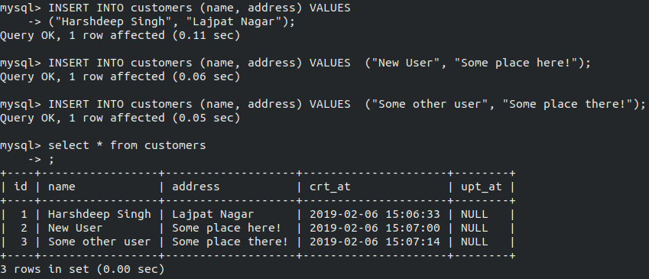

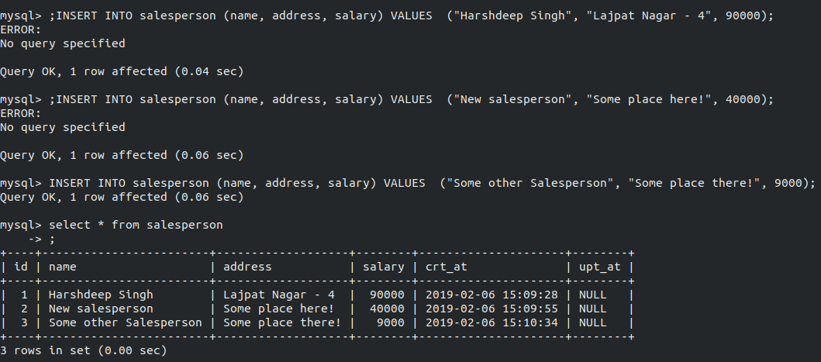

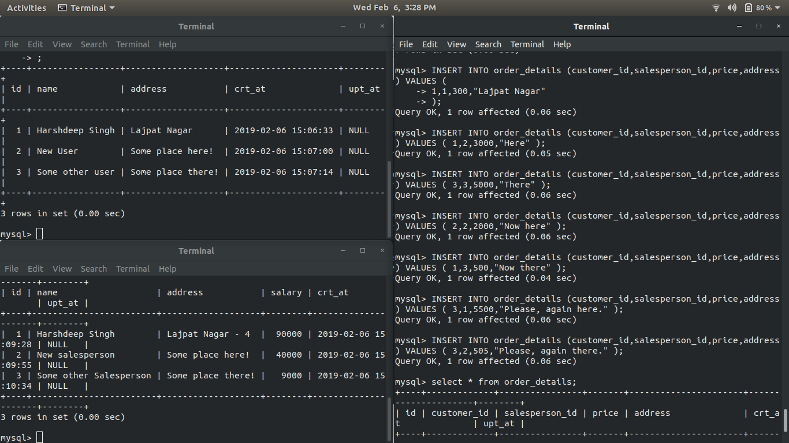

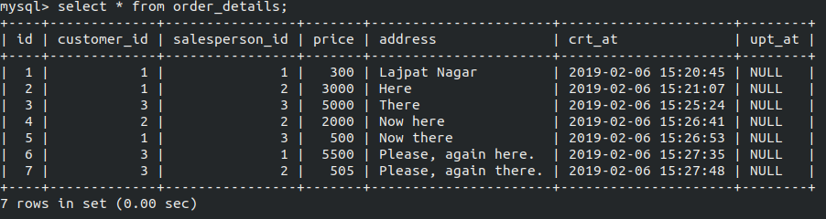

**Find the sales person have multiple orders.**

The fuction *count()* return the number of records satisfying a particular condition.

Here, it is used to get the number of orders present for a particular salesperson.

Screenshot(s)

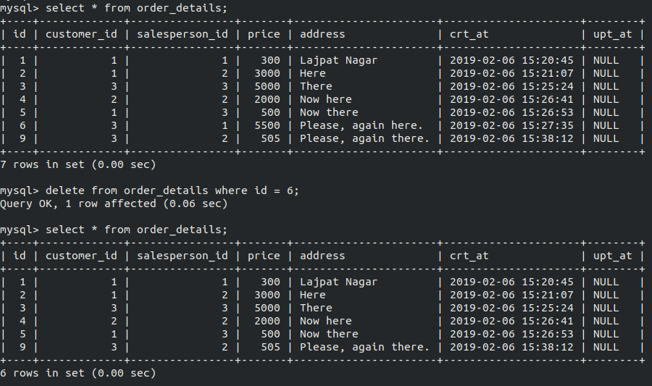

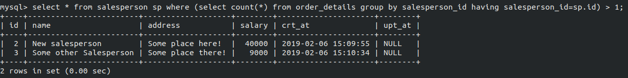

**Find the all sales person details along with order details**

Inner Join creates a result set joining two tables on the basis of a common column, the foreign key.

A foreign key is a constraint which is used to link two tables, the primary key of the other table is made the foreign key of this table.

Screenshot(s)

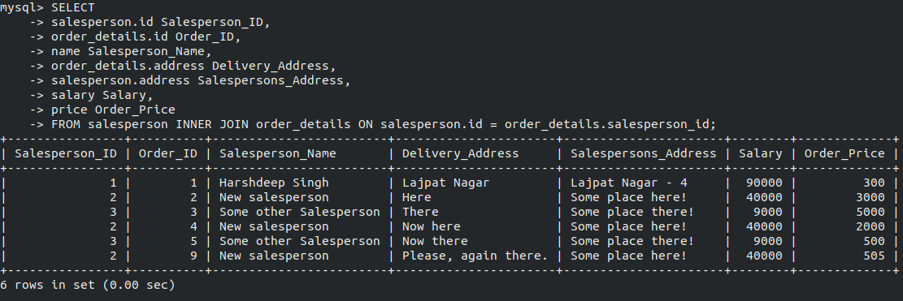

**Create index**

Index is also a kind of constraint we list with the mysql to make the *select* operation on the basis of that indexed column faster. Every key is an index.

Screenshot(s)

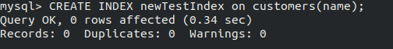

**How to show index on a table**

*Show index from <table Name>* is used to show all the indexes of a table.

Screenshot(s)

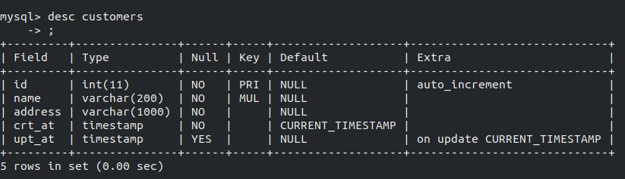

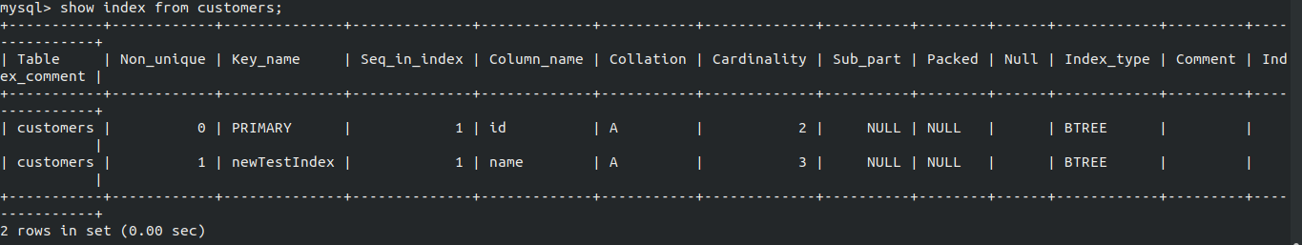

**Find the order number, sale person name, along with the customer to whom that order belongs to**

Here we want data from all the three tables, *customers, salesperson* and *order_details*. Hence we’re going to perform inner join on all the three tables.

Screenshot(s)

